WHATSAPP CLONE

# A PROJECT REPORT

**For**

**Mini Project (KCA 353)**

**Session (2023-24)**

# Submitted by

# Abhinav Saini

**(2200290140005)**

**Abhishek Chaudhary**

**(2200290140006)**

**Submitted in partial fulfillment of the**

**Requirements for the Degree of**

MASTER OF COMPUTER APPLICATION

Under the Supervision of

Ms. Neelam Rawat

Associate Professor



Submitted to

DEPARTMENT OF COMPUTER APPLICATIONS

KIET GROUP OF INSTITUTIONS, GHAZIABAD

UTTAR PRADESH – 201206

(JANUARY - 2024)

DECLARATION

I hereby declare that the work presented in this report entitled “WhatsApp Clone”, was carried out by me. I have not submitted the matter embodied in this report for the award of any other degree or diploma of any other University or Institute. I have given due credit to the original authors/sources for all the words, ideas, diagrams, graphics, computer programs, experiments, results, that are not my original contribution. I have used quotation marks to identify verbatim sentences and given credit to the original authors/sources. I affirm that no portion of my work is plagiarized, and the experiments and results reported in the report are not manipulated. In the event of a complaint of plagiarism and the manipulation of the experiments and results, I shall be fully responsible and answerable.

**Name:** Abhinav Saini (2200290140005)

Abhishek Chaudhary (2200290140006)

**(Candidate Signature)**

# CERTIFICATE

Certified that Abhinav Saini **2200290140005** have carried out the project work having “WhatsApp Clone" for Master of Computer Applications from Dr. A.P.J. Abdul Kalam Technical University (AKTU**)**, Lucknow under my supervision. The project report embodies original work, and studies are carried out by the student himself / herself and the contents of the project report do not form the basis for the award of any other degree to the candidate or to anybody else from this or any other University/Institution.

**Date:**

**Abhinav Saini (22002901400005)**

**Abhishek Chaudhary (2200290140006)**

This is to certify that the above statement made by the candidate is correct to the best of my knowledge.

Date:

**Ms. Neelam Rawat Dr. Arun Tripathi**

**Associate Professor Head**

**Department of Computer Department of Computer**

**Applications Applications**

**KIET Group of Institutions, KIET Group of Institutions,**

**Ghaziabad Ghaziabad**

# WHATSAPP CLONE

# Abhinav Saini, Abhishek Chaudhary

# ABSTRACT

The project aims to develop a cross-platform messaging application, serving as a functional clone of WhatsApp. Utilizing modern web and mobile technologies, the system provides a seamless user experience with features such as user authentication, real-time messaging, multimedia sharing, and push notifications. The frontend employs frameworks like React Native or Flutter for mobile applications or native development for iOS and Android platforms. The backend, powered by technologies such as Node.js, Express, or Firebase, facilitates secure user authentication through JWT or Auth mechanisms. Leveraging a real-time communication protocol, the application ensures instant message delivery and supports multimedia file sharing, including images and videos.The user interface incorporates a chat module with features like emoji support, message status indicators, and timestamps. Robust security measures are implemented, ensuring HTTPS for data transmission and thorough validation of user inputs to prevent security vulnerabilities. Additionally, the system includes functionalities for managing contacts, user search, and profile customization. The deployment involves hosting the backend on platforms like AWS or Heroku and distributing the frontend through app stores. Continuous improvement, guided by user feedback, ensures an evolving and responsive application. The project's documentation provides comprehensive insights into code structure, setup procedures, and ongoing maintenance, promoting transparency and ease of use for developers and stakeholders alike.

# 

# ACKNOWLEDGEMENT

Success in life is never attained single-handedly. My deepest gratitude goes to my thesis supervisor, **Ms. Neelam Rawat** for her guidance, help and encouragement throughout my research work. Their enlightening ideas, comments, and suggestions. Words are not enough to express my gratitude to **Dr. Arun Kumar Tripathi**, Professor and Head, Department of Computer Applications, for his insightful comments and administrative help at various occasions. Fortunately, I have many understanding friends, who have helped me a lot on many critical conditions.

Finally, my sincere thanks go to my family members and all those who have directly and indirectly provided me with moral support and other kind of help. Without their support, completion of this work would not have been possible in time. They keep my life filled with enjoyment and happiness.

**Name: Abhinav Saini (2200290140005)**

**Abhishek Chaudhary (2200290140006)**

**TABLE OF CONTENTS**

|  |  |  |  |
| --- | --- | --- | --- |
|  | Declaration  Certificate |  | ii  iii |
|  | Abstract |  | iv |
|  | Acknowledgment |  | v |
|  | Table of Contents |  | vi-vii |
|  | List of Figures |  | viii |
|  |  |  |  |
| 1. | Introduction |  | 9-11 |
|  | 1.1 | Overview | 9-10 |
|  | 1.2 | Objective | 10 |
|  | 1.3 | Project Features | 11 |
| 2. | Literature Review |  | 12-14 |
| 3. | Feasibility Study |  | 15-19 |
|  | 3.1 | Operational Feasibility | 15-16 |
|  | 3.2 | Technical feasibility | 16-17 |
|  | 3.3 | Economical Feasibility | 18 |
|  | 3.4 | Behavioral Feasibility | 19 |
| 4. | Requirement Analysis |  | 20-23 |
|  | 4.1 | Introduction | 20 |
|  | 4.2 | Scrum Methodologies | 20-21 |
|  | 4.3 | Functional Requirement | 21-22 |
|  | 4.4 | Non-Functional Requirement | 22-23 |
|  | 4.5 | Software Requirement | 23 |
|  | 4.6 | Hardware Requirement | 23 |

|  |  |  |  |
| --- | --- | --- | --- |
| 5. | System Architecture and Design |  | 24-27 |
|  | 5.1 | Frontend Architecture | 24-25 |
|  | 5.2 | Backend Architecture | 25-27 |
| 6. | Implementation and Result |  | 28-31 |
|  | 6.2 | Landing Page | 28 |
|  | 6.2 | User Authentication | 29 |
|  | 6.3 | Home Page | 30 |
|  | 6.4 | Chat Interface | 31 |
| 7. | Conclusion |  | 32 |
| 8. | Refrences |  | 33 |

**LIST OF FIGURES**

|  |  |  |  |  |
| --- | --- | --- | --- | --- |
| **Figure No.** | **Name of Figure** |  | **Page No.** | |
| 6.1 | Landing Page |  |  | 28 |
| 6.2 | User Authentication |  |  | 29 |
| 6.3 | Home Page |  |  | 30 |
| 6.4 | Chat Interface |  |  | 31 |

**CHAPTER 1**

**INTRODUCTION**

* 1. **OVERVIEW**

The WhatsApp Clone project adopts a robust technology stack, incorporating React.js for the frontend, Firebase for the backend, and Material-UI for the user interface. This amalgamation of technologies is chosen for its efficiency, scalability, and the ability to create a seamless and visually appealing user experience.

React.js serves as the cornerstone of the frontend development, providing a dynamic and responsive user interface. With its component-based architecture, React allows for the creation of modular and reusable UI elements, streamlining the development process. The virtual DOM ensures efficient updates, contributing to the overall performance of the application. React's declarative syntax enhances code readability, facilitating ease of understanding and maintenance.

On the backend, Firebase offers a comprehensive suite of services, making it an ideal choice for the WhatsApp Clone project. The Realtime Database supports instant data synchronization, crucial for real-time messaging applications. Firebase Authentication ensures secure user authentication, and Cloud Functions enable serverless backend logic. Cloud Storage is utilized for storing and serving multimedia files, contributing to the multimedia sharing functionality of the application.

Material-UI is employed for crafting the user interface components, implementing Google's Material Design principles. This React UI framework provides a range of pre-designed components, fostering the creation of a visually cohesive and intuitive user interface. The theming capabilities of Material-UI allow for easy customization, aligning the application with specific branding and design preferences.

The integration of React.js, Firebase, and Material-UI results in a powerful synergy. React.js ensures a dynamic and efficient frontend, Firebase handles the backend infrastructure with real-time capabilities, and Material-UI contributes to a visually cohesive and intuitive user interface. This combination of technologies is not only popular and well-supported but also allows for rapid development, making it an ideal choice for creating a feature-rich messaging application like WhatsApp Clone.

In summary, the WhatsApp Clone project adopts React.js, Firebase, and Material-UI to create a robust, scalable, and visually appealing messaging application. The chosen technologies collectively contribute to the efficiency, security, and user experience of the application, aligning with the project's goal of delivering a cutting-edge and user-centric messaging platform.

# OBJECTIVE

The primary objective of the WhatsApp Clone project is to develop a cross-platform messaging application that replicates the core functionalities of WhatsApp while leveraging modern technologies for enhanced user experience, security, and scalability. The project aims to create a user-friendly interface using React.js, ensuring a dynamic and responsive frontend that aligns with contemporary design standards.

The utilization of Firebase for the backend infrastructure serves the purpose of establishing a robust foundation for real-time messaging, user authentication, and multimedia sharing. The project focuses on harnessing Firebase's Realtime Database for instantaneous data synchronization, enabling seamless and efficient communication between users. Security is paramount, and Firebase Authentication is employed to ensure secure user logins through industry-standard methods such as JWT or OAuth.

The integration of Material-UI for the user interface design is driven by the goal of providing an aesthetically pleasing and intuitive experience. By adhering to Google's Material Design principles, the project aims to create a visually cohesive and responsive interface that enhances user engagement.

Furthermore, the project seeks to deploy the backend on reliable platforms like AWS or Heroku, ensuring stability and scalability. The frontend, developed with React Native or Flutter, is intended for distribution on major app stores such as Google Play Store and Apple App Store, making the application widely accessible.

Continuous improvement is inherent in the project's philosophy, guided by user feedback to adapt to evolving needs and technological advancements.

# PROJECT FEATURE

The WhatsApp Clone project incorporates a diverse range of features to provide users with a comprehensive and modern messaging experience. Emulating the core functionalities of WhatsApp, these features are designed to optimize usability, security, and overall versatility.

* **Real-Time Messaging:** The project's foundation is built upon a robust real-time messaging system. By utilizing technologies like WebSocket and Firebase Realtime Database, the application ensures the instantaneous delivery of messages, creating a seamless and dynamic communication experience. This feature allows users to engage in real-time conversations, facilitating quick and efficient communication.
* **User Authentication:** A strong emphasis is placed on security, and the project implements a secure user authentication system. Users can register securely, and authentication methods such as JSON Web Tokens (JWT) or OAuth are employed to validate and protect user identities. This ensures a safe and trustworthy environment for users to interact within the messaging platform.
* **Multimedia Sharing:** Beyond text-based communication, the project facilitates multimedia sharing capabilities. Users can share images and videos seamlessly, enhancing the versatility of communication within the application. The system supports features such as image and video previews, contributing to a visually enriched messaging experience.
* **User-Friendly Interface:** The user interface is meticulously designed for user-friendliness. Leveraging React.js and Material-UI, the application offers an intuitive and aesthetically pleasing interface. The interface design adheres to Google's Material Design principles, providing a visually cohesive and responsive environment for users to navigate.
* **Continuous Improvement:** In line with a user-centric approach, the project embraces continuous improvement. User feedback serves as a guide for enhancements and feature additions, ensuring that the application remains responsive to evolving needs and technological advancements. This iterative process contributes to the ongoing evolution and optimization of the messaging platform.

CHAPTER 2

# LITERATURE REVIEW

# 2.1 LITERATURE INTRODUCTION

WhatsApp is a widely used mobile messaging application that offers various benefits compared to traditional SMS. This literature review aims to provide an overview of the research findings related to WhatsApp and its usage in different contexts. The review highlights the advantages and disadvantages of WhatsApp, its applications in different settings, and the challenges associated with its adoption. Additionally, it identifies gaps in the existing literature and suggests potential areas for future research.

# 2.2 WHATSAPP AS A MOBILE MESSAGING APPLICATION

Research conducted by Church and Oliveira (2013) compares mobile instant messaging behaviors on WhatsApp with traditional SMS. The study highlights that WhatsApp offers benefits such as cost-effectiveness, a sense of community, and immediacy compared to SMS. However, SMS is considered more reliable and privacy-preserving for mobile communication. This finding suggests that while WhatsApp provides certain advantages, there are still concerns regarding its reliability and privacy.

# 2.3 WHATSAPP IN EDUCATION

Bouhnik and Mor (2014) explore the usage of WhatsApp in classroom settings for communication between teachers and students. The study reveals that WhatsApp is used for nurturing the social atmosphere, creating dialogue, encouraging sharing among students, and serving as a learning platform. WhatsApp is preferred due to its technical advantages, including simple operation, low cost, availability, and immediacy. This research finding demonstrates the potential of WhatsApp as an effective tool in educational environments.

# 2.4 ADOPTION OF SECURE COMMUNICATION TOOLS

The adoption of secure communication tools like WhatsApp is hindered by fragmented user bases and incompatible tools, as identified by Abu-Salma et al. (2017). The study highlights that many users do not understand the concept of end-to-end encryption and do not value the protection it offers. This finding suggests the need for user education and awareness regarding the importance of secure communication tools like WhatsApp.

# 2.5 WHATSAPP IN REMOTE TEACHING DURING PANDEMICS

Amin and Sundari (2020) investigate the preferences of EFL students on digital platforms during emergency remote teaching, including WhatsApp. The study reveals that WhatsApp, along with Cisco WebEx Meeting and Google Classroom, is highly preferred by Indonesian EFL students. WhatsApp is particularly favored for meaning focus, learner fit, positive impact, and practicality. This finding emphasizes the suitability of WhatsApp as a remote teaching platform during situations like the Covid-19 pandemic.

# 2.6 WHATSAPP IN COMMUNITY HEALTH WORK

Henry et al. (2016) conducted qualitative research on the use of WhatsApp by Community Health Workers (CHWs) and their supervisors. The study findings indicate that WhatsApp is used to document work, promote team building, and achieve supervisory objectives such as creating a social environment, sharing communication and information, and promoting quality of services. This research highlights the potential of WhatsApp in enhancing the supervision of CHWs and improving the quality of healthcare services.

2.7 SECURITY AND RELIABILITY

Karpísek et al. (2015) explore the security and reliability goals of WhatsApp and other communication protocols. The study reveals shortcomings in the security and reliability of protocols like Signal, WhatsApp, and Threema. The researchers propose generic countermeasures to enhance the required security and reliability goals. This finding emphasizes the importance of addressing security and reliability concerns in the design and implementation of communication protocols like WhatsApp.

# 2.8 WHATSAPP IN HEALTHCARE SETTINGS

WhatsApp is widely used by individuals and organizations in healthcare settings for sharing information, supporting supervision, professional development, and team building, as identified by Rösler et al. (2018). The use of WhatsApp in healthcare is driven by perceived advantages and benefits in clinical practice. This research finding suggests the potential of WhatsApp in improving communication and collaboration in healthcare settings.

# 2.9 WHATSAPP FOR ADHERENCE TO ANTIRETROVIRAL THERAPY

Mobile phone-based interventions using WhatsApp, including SMS and voice calls, have shown to improve adherence to antiretroviral therapy (ART) compared to control conditions, according to Kaufmann and Peil (2019). The study highlights the effectiveness of scheduled SMS interventions in improving adherence. This finding emphasizes the potential of WhatsApp as a tool for promoting adherence to medication regimens.

# 2.10 WHATSAPP IN LANGUAGE LEARNING

WhatsApp is used as a platform for online learning in language courses, facilitating interaction and improving oral skills in second-language learners, as found by Frosch et al. (2016). The study highlights that WhatsApp provides opportunities for natural language practice and contextualized language use. This research finding demonstrates the potential of WhatsApp as an effective mobile-assisted language learning application.

# 2.11 WHATSAPP FOR FOCUS GROUPS

WhatsApp group chat can be used as an online format for focus groups, generating well-elaborated responses and group interaction, as discussed by Dorwal et al. (2015). However, the study also suggests that the quantity and richness of conversation may not match in-person focus groups. This finding highlights the potential of WhatsApp as an alternative platform for conducting focus groups, while also acknowledging certain limitations compared to in-person interactions.

# 

# CHAPTER 3

**FEASIBILITY STUDY**

After doing the project, study and analyzing all the existing or required functionalities of the system, the next task is to do the feasibility study for the project. All projects are feasible-given unlimited resources and in finite time. Feasibility study includes consideration of all the possible ways to provide a solution to the given problem. The proposed solution should satisfy all the user requirements and should be flexible enough so that future changes can be easily done based on the future upcoming requirements. There are three parts in feasibility study

1. Operational Feasibility
2. Technical Feasibility
3. Economic Feasibility
4. Behavioral Feasibility

# OPERATIONAL FEASIBILITY

Operational feasibility refers to the assessment of whether a project can be successfully implemented and integrated into the existing operational infrastructure. In the case of this augmented reality project, evaluating its operational feasibility involves considering various factors that impact its practical implementation.

* **User Adaptation and Training:** Operational feasibility involves evaluating how easily users can adapt to the new messaging application. The user interface design, navigation, and overall user experience should align with user expectations. Adequate training resources and documentation should be provided to ensure a smooth transition for end-users. A user-friendly interface built with Material-UI contributes to operational feasibility by reducing the learning curve for both existing and new users.Technical Integration:
* **Collaboration and Communication:** Operational feasibility emphasizes effective collaboration and communication among team members during and after the implementation of the project. The agile development approach, influenced by React.js and Firebase's real-time capabilities, fosters collaboration and adaptability within the organization. Efficient communication channels and collaboration tools should be in place to support the ongoing operational requirements.
* **Scalability and Maintenance:** Operational feasibility includes considerations for the scalability and maintenance of the system. Firebase's real-time database capabilities and cloud services contribute to the scalability of the messaging application. A well-defined maintenance plan should be in place, outlining procedures for updates, bug fixes, and continuous improvement. The operational framework should support scalability to accommodate potential increases in user numbers and messaging activity.
* **User Feedback Mechanisms:** Incorporating user feedback mechanisms is essential for operational feasibility. The project should establish channels for users to provide feedback on their experiences, report issues, and suggest improvements. Continuous improvement based on user feedback ensures that the messaging application remains aligned with user expectations and operational requirements. An agile, feedback-driven development approach supports ongoing operational success by addressing user needs and concerns promptly.By evaluating these operational feasibility factors, the project team can determine the practicality and viability of implementing the augmented reality solution within the college's existing operational infrastructure.

# TECHNICAL FEASIBILITY

Technical feasibility refers to the evaluation of whether the proposed augmented reality project can be successfully developed, implemented, and integrated from a technical standpoint. Assessing technical feasibility involves considering various factors related to the project's technological aspects. Here are some key considerations:

* **Technology Stack Suitability:** React.js, Firebase, and Material-UI are chosen for their proven capabilities in web and mobile app development. React.js, with its component-based architecture, facilitates modular and efficient UI development. Firebase offers real-time data synchronization and authentication, aligning well with the requirements of a messaging application. Material-UI provides a set of pre-designed React components for a visually cohesive and responsive user interface.
* **Compatibility and Integration:** The compatibility of React.js, Firebase, and Material-UI ensures smooth integration. React.js can seamlessly integrate with Firebase for real-time updates, and Material-UI components can be easily incorporated to create an aesthetically pleasing user interface. This interoperability minimizes technical challenges during the development phase, contributing to the technical feasibility of the project.
* **Scalability:** Firebase, known for its scalability, aligns with the project's requirement for real-time messaging and data synchronization. The platform can efficiently handle increasing loads as the user base expands. React.js also supports scalability, and with proper architecture and coding practices, the application can be optimized to handle growing demands, enhancing its technical feasibility for potential future growth.
* **Development Team Proficiency:** The technical expertise of the development team plays a crucial role in project success. If the team is already proficient in React.js and Material-UI, they can leverage their skills to expedite development. Firebase's documentation and ease of integration further support the team in efficiently utilizing these technologies, contributing to the technical feasibility of the project.
* **Documentation and Community Support:** The availability of comprehensive documentation and community support for React.js, Firebase, and Material-UI is a key factor in technical feasibility. Robust documentation aids in understanding the intricacies of each technology, while community support ensures that potential issues can be addressed effectively. The widespread usage of these technologies implies a wealth of resources and forums, enhancing the technical feasibility by providing a reliable knowledge base.
* **Security Considerations:** Technical feasibility involves evaluating the security features of the chosen technologies. Firebase, for example, offers robust authentication mechanisms, ensuring secure user logins. React.js allows for the implementation of secure coding practices. The ability to handle encryption, secure data transmission, and protect against common security threats contributes to the overall technical feasibility of the project.
* **Performance Optimization:** Technical feasibility includes considerations for optimizing the performance of the application. React.js's virtual DOM ensures efficient updates, and Firebase's real-time capabilities contribute to responsive data synchronization. Material-UI's theming capabilities allow for customization while maintaining optimal performance.

The ability to implement performance optimizations ensures a smooth and responsive user experience, enhancing the technical feasibility of the project.

By considering these technical feasibility factors, the project team can determine the practicality and viability of implementing the augmented reality solution, ensuring that the necessary technology and resources are available to successfully develop and deploy the application.

# ECONOMICAL FEASIBILITY

Establishing Economic feasibility refers to the assessment of whether the proposed augmented reality project is financially viable and justifiable. It involves analyzing the project's costs and potential benefits to determine if the investment in the project is economically feasible. Here are key considerations for evaluating the economic feasibility of the project:

* **Labor Costs:** The primary economic consideration is the cost of human resources, including developers, designers, and project managers. The wages or contract fees associated with these professionals impact the overall development costs.
* **Training Costs:** If additional training is required for the development team, these costs contribute to the economic feasibility. Training investments can enhance team efficiency and project success.
* **Software Licenses:** While React.js and Material-UI are open-source, any costs associated with specific tools, software licenses, or premium features required for development should be considered. Firebase's freemium model may have associated costs based on usage.
* **Cloud Services:** Infrastructure costs are a significant economic factor. Firebase's hosting on Google Cloud Platform incurs expenses, particularly as the user base and usage grow. Ongoing monitoring of these costs is essential for economic feasibility.
* **Domain and Hosting**: Purchasing a domain name and hosting services adds to the economic considerations but is a necessary investment for establishing an online presence.
* **Maintenance Costs:** Ongoing maintenance, including bug fixes, updates, and enhancements, represents a continuous economic commitment. Budgeting for regular maintenance ensures the sustained performance and relevance of the application.
* **Support Costs:** If a support team is required for user assistance, these costs contribute to the economic feasibility. A responsive support system enhances user satisfaction and retention.
* **App Store Fees:** Distribution through app stores may incur fees for submissions, updates, or in-app purchases. These costs should be factored into the economic analysis.
* **Marketing Costs**: Economic feasibility involves considering expenses related to marketing and promotional activities.

# 3.4 BEHAVIORAL FEASIBILITY

Behavioral feasibility refers to the assessment of whether the proposed augmented reality project is acceptable and practical from a behavioral or human perspective. It involves considering the potential impact on user behavior, attitudes, and acceptance of the project. Here are key considerations for evaluating the behavioral feasibility of the project:

* **User Acceptance:** Evaluate the potential acceptance and willingness of the target users, such as prospective students, to engage with the augmented reality experience. Conduct surveys, interviews, or focus groups to gather feedback and understand their attitudes towards augmented reality technology, their preferences for interactive experiences, and their willingness to use the application.
* **User Experience**: Assess the potential user experience and interaction with the augmented reality application. Consider factors such as ease of use, intuitiveness of the interface, responsiveness of the application, and the level of engagement and enjoyment it provides. It is important to ensure that the augmented reality experience adds value and enhances the overall perception of the college.
* **Training and Familiarity:** Evaluate the feasibility of providing necessary training or guidance to users who will be demonstrating the augmented reality features, such as college staff or admissions personnel. Consider the level of technical knowledge or familiarity required to effectively showcase the application to prospective students, and assess the availability of resources and support to facilitate their training.
* **Psychological Impact:** Consider the potential psychological impact of the augmented reality experience on users. Assess factors such as comfort level, immersion, presence, and potential concerns regarding motion sickness or disorientation. It is important to ensure that the augmented reality experience is designed in a way that is engaging, enjoyable, and does not cause any negative psychological effects.
* **Cultural and Ethical Considerations:** Evaluate the project's alignment with cultural norms, ethical standards, and privacy regulations. Ensure that the augmented reality application respects user privacy, obtains necessary permissions for data collection, and adheres to ethical guidelines in terms of content presentation and information sharing.
* **User Feedback and Iterative Improvement:** Establish mechanisms for gathering user feedback and incorporating it into the iterative improvement of the application. Regularly collect feedback from users to identify areas for enhancement, address usability issues, and improve the overall user experience.
* **Organizational Acceptance and Support:** Assess the readiness and acceptance of the college administration, staff, and stakeholders to embrace and support the augmented reality project.

**CHAPTER 4**

**REQUIREMENT ANALYSIS**

* 1. **METHODOLOGIES FOLLOWED**

In the development of an augmented reality project, various methodologies can be employed. One commonly used methodology is the Scrum framework, which is an agile approach to project management. Here's an explanation of how the Scrum methodology can be applied:

## SCRUM METHODOLOGY:

Description: Scrum is an iterative and incremental framework that promotes collaboration, flexibility, and continuous improvement. It divides the project into time- bound iterations called sprints, typically lasting 2-4 weeks, during which a set of prioritized tasks are completed.Application, we utilize the Scrum methodology as follows:

* **Product Backlog:** Create a product backlog, which is a prioritized list of features, functionalities, and tasks required for the augmented reality project. The backlog items are typically defined as user stories, representing the needs and expectations of the end-users.
* **Sprint Planning:** At the beginning of each sprint, conduct a sprint planning meeting. During this meeting, the team selects a subset of items from the product backlog to be worked on during the sprint. The team estimates the effort required for each task and determines the sprint goal, which represents the desired outcome of the sprint.
* **Daily Scrum:** Hold daily scrum meetings, also known as daily stand-ups. These brief meetings serve to synchronize the team, discuss progress, and identify any obstacles or issues that need to be addressed. Each team member shares their accomplishments, plans, and potential challenges.
* **Sprint Execution:** Throughout the sprint, the team works on the tasks identified during the sprint planning.
* **Sprint Review:** At the end of each sprint, hold a sprint review meeting to showcase the completed work to stakeholders, including the augmented reality application's features, functionalities, and any other deliverables. Collect feedback and review whether the sprint goal was achieved.
* **Sprint Retrospective:** After the sprint review, conduct a sprint retrospective meeting. This retrospective allows the team to reflect on the sprint, discuss what went well and what could be improved, and identify action items for enhancing the development process in subsequent sprints.
* **Iterative Development:** Repeat the sprint cycle by selecting new items from the product backlog and continuing the iterative development process. The team learns from each sprint, adjusts priorities, and continuously improves the augmented reality application based on feedback and evolving requirements.

By applying the Scrum methodology, the project team benefits from improved collaboration, flexibility in adapting to changing requirements, and regular feedback cycles. The iterative nature of Scrum allows for the early and continuous delivery of valuable features, ensuring that the augmented reality project remains aligned with user expectations and generates a high-quality product.

# 4.3 FUNCTIONAL REQUIREMENT

Functional requirements specify what the system or software should do or the actions it should perform. They describe the intended functionality, features, and capabilities of the system. These requirements outline the system's behavior, inputs, outputs, and interactions with users or other systems. Functional requirements are typically specific, measurable, and verifiable. Examples include user authentication, data input validation, report generation, and system integration.

* **User Registration and Login**: Users should be able to create accounts with necessary information. A secure authentication mechanism should allow users to log in with valid credentials. Password recovery and reset functionalities enhance account security.
* **User Profiles:** Users should create and edit profiles, including profile pictures, status updates, and relevant personal information.
* **Real-Time Messaging:** Enable users to send and receive real-time text messages. Implement features like read receipts and typing indicators for a dynamic user experience.
* **Multimedia Sharing:** Allow users to share multimedia files, including images, videos, and audio messages. Ensure proper media handling, storage, and display within the chat interface.
* **Push Notifications:** Implement push notifications to notify users of new messages and updates. Allow users to customize notification preferences.
* **Search Functionality:** Include a search feature to help users find and connect with contacts easily. Enable searching within chat histories.
* **Emojis and Stickers:** Integrate emojis and stickers to enhance user expression in messages.
* **End-to-End Encryption:** Implement end-to-end encryption to ensure the security and privacy of user communications. Encrypt messages in transit and at rest.
* **Responsive Design:** Ensure a responsive and adaptive design for a consistent user experience across different devices and screen sizes.
* **Cross-Browser Compatibility:** Support major web browsers to ensure the application works seamlessly on different platforms.

# 4.4 NON-FUNCTIONAL REQUIREMENT

Non-functional requirements, also known as quality attributes or constraints, define the characteristics and constraints of the system beyond its functionality. These requirements describe how the system should perform, rather than what it should do. Non-functional requirements are often related to performance, reliability, security, usability, and other aspects that contribute to the overall system quality. Examples include response time, system availability, data encryption, user interface design, and regulatory compliance.

* **Performance:** The application should have fast and responsive image recognition, with minimal latency or delay in detecting and overlaying digital objects on the image targets. It should also deliver smooth playback of videos or animations without any significant lag.
* **User Interface (UI) and User Experience (UX):** The application should have an intuitive and user-friendly interface, with clear instructions or visual cues to guide users in scanning the college brochure and interacting with the augmented reality content. The user experience should be immersive, engaging, and visually appealing.
* **Compatibility and Device Support:** The application should be compatible with a wide range of smartphones or devices, supporting both Android and iOS platforms. It should consider various screen sizes, resolutions, and camera capabilities to ensure a consistent experience across different devices.
* **Stability and Reliability:** The application should be stable and reliable, capable of handling potential errors or exceptions during image recognition or content playback. It should gracefully handle situations such as low lighting conditions or variations in brochure positioning.
* **Security and Privacy:** The application should prioritize user privacy and data security, adhering to relevant privacy regulations. It should obtain necessary permissions for accessing device features, such as camera and storage, and ensure secure transmission and storage of any user-related data.
* **Scalability:** The application should have the potential to scale, accommodating future updates, additional content, or expanded functionality. It should be designed in a modular and extensible manner, allowing for easy integration of new image targets or features without significant rework.

# 4.5 SOFTWARE REQUIREMENT

**Table 4.1 Software Requirement**

|  |  |  |
| --- | --- | --- |
| **S. NO.** | **DESCRIPTION** | **TYPE** |
| 1 | Operating System | Windows |
| 2 | Language | React |
| 3 | IDE | Microsoft Visual Studio |

# 4.6 HARDWARE REQUIREMENT

**Table 4.2 Hardware Requirement**

|  |  |  |
| --- | --- | --- |
| **S. NO.** | **DESCRIPTION** | **TYPE** |
| 1 | Hardware | Apple M2 Processor |
| 2 | Clock Speed | 3.0GHz |
| 3 | RAM | 8GB |
| 4 | SSD | 512GB |

# CHAPTER 5

**SYSTEM ARCHITECTURE AND DESIGN**

# 5.1 FRONTEND ARCHITECTURE

The frontend architecture of the WhatsApp Clone project is strategically designed to optimize user interaction and visual appeal. The theoretical description of this architecture encompasses key principles, features, and considerations.

# 5.1.1 REACT.JS COMPONENTS:

* **Modular Component Structure:** React.js promotes a modular approach to frontend development. Components, the building blocks of the application, encapsulate specific functionalities.

For example, the User Profile component might include user details and profile picture rendering.

* **Hierarchical Component Organization:** Components are organized hierarchically, representing the structure of the application. A clear hierarchy simplifies code maintenance and readability.

The application may have a hierarchy of components such as App > Chat Interface > Message List > Message.

# 5.1.2 MATERIAL-UI INTEGRATION:

* **Consistent Design Language:** Material-UI, a React UI framework, is integrated to leverage pre-designed components following the principles of Material Design.

This ensures a consistent and aesthetically pleasing design language across the application.

* **Enhanced UI Elements:** Material-UI components include enhanced UI elements like buttons, input fields, and navigation elements, providing a modern and intuitive user interface.

The use of Material-UI components contributes to a visually cohesive and engaging user experience.

# 5.1.3 RESPONSIVE DESIGN:

* **Adaptive Layouts:** Responsive design principles are implemented to ensure the application adapts seamlessly to various screen sizes and devices.

CSS media queries and flexbox/grid layouts are employed to create adaptive and user-friendly interfaces.

# 5.1.4 COMPONENT INTERACTION:

* **State Management:** React.js facilitates state management to handle dynamic content and user interactions.

Component state and props are utilized to update and propagate data, ensuring a real-time and interactive user experience.

* **Event Handling:** Event handling mechanisms in React.js, such as on Click and on Change, are employed to capture and respond to user actions.For instance, clicking a button triggers a specific action like sending a message or navigating to a different screen.

# 5.1.5 FLOW OF DATA:

* **Data Flow Between Components:** React's unidirectional data flow ensures a clear and predictable flow of data between components.Parent components pass data as props to child components, maintaining a structured and efficient data flow.
* **Asynchronous Updates:** Asynchronous updates are handled seamlessly through React's virtual DOM, enabling efficient rendering and minimizing the need for full-page reloads.Real-time updates, such as new message notifications, are reflected asynchronously in the user interface.

# BACKEND ARCHITECTURE:

5.2.1 FIREBASE REALTIME DATABASE:The Firebase Realtime Database acts as a NoSQL cloud database, using a hierarchical JSON-like structure. It stores essential data nodes for users, messages, groups, and other entities.

* **Users Node:** This node contains individual user profiles with unique user IDs. Each user entry includes details such as usernames, profile pictures, and other relevant information.
* **Messages Node:** Messages exchanged between users are stored here. Each message entry includes sender and receiver details, timestamps, and the message content. The hierarchical structure allows for efficient retrieval and storage of messages.

**5.2.2 FIREBASE AUTHENTICATION:** Firebase Authentication is utilized to manage user registration and login securely. It provides a token-based authentication mechanism where users receive secure tokens upon successful login. These tokens are then used to authenticate subsequent requests, ensuring that only authenticated users can access specific resources within the application.

**5.2.3 CLOUD FUNCTIONS**: Firebase Cloud Functions may be integrated for serverless computing. These functions allow the execution of specific backend tasks without the need for a dedicated server. For example, cloud functions can be triggered by database events or HTTP requests to perform tasks such as data validation, processing, or sending push notifications.

**5.2.4 DATABASE ARCHITECTURE:** The database architecture revolves around the Firebase Realtime Database, chosen for its ability to handle real-time data synchronization and its flexibility in representing hierarchical data structures.

* **Database Schema:** The Firebase Realtime Database schema includes nodes for users, messages, groups, and other entities. Each node is organized in a hierarchical structure, representing relationships between different entities. This structure facilitates efficient data retrieval and storage.
* **Users Node:** Contains individual user profiles.
* **Messages Node:** Stores messages exchanged between users.

**5.2.5. AUTHENTICATION AND SECURITY:** Security measures are paramount in the WhatsApp Clone project to ensure the privacy and integrity of user data.

* **End-to-End Encryption:** To safeguard user communications, end-to-end encryption is implemented. This encryption method ensures that messages are encrypted at the sender's end and decrypted only at the recipient's end, preventing unauthorized access during transmission.
* **Token-Based Authentication:** Firebase Authentication employs a token-based authentication mechanism. Upon successful login, users receive secure tokens that are used to authenticate subsequent requests. This adds an extra layer of security, ensuring that only authenticated users can access specific resources.

**5.2.6 MESSAGING ENGINE:** The messaging engine is a crucial component responsible for managing real-time message delivery and updates within the application.

* **Real-Time Messaging:** Real-time messaging capabilities are achieved through mechanisms such as WebSocket connections or Firebase Realtime Database triggers. When a user sends a message, the messaging engine ensures its immediate propagation to the recipient and updates the conversation in real-time. This creates a dynamic and interactive user experience, similar to the real-time nature of messaging applications.
* **Message Queuing:** To handle high traffic efficiently, the system may incorporate message queuing. This ensures that messages are processed in an organized manner, preventing bottlenecks in the messaging engine during peak usage.

**5.2.7 USER INTERFACE (UI) DESIGN:** The user interface design is a critical aspect of the WhatsApp Clone project, focusing on creating an intuitive and visually appealing experience.

* **Modular Component Structure:**React.js components follow a modular structure, allowing for the creation of reusable UI elements. Each component represents a specific feature or section of the application, such as user profiles, chat interfaces, and settings. The modular structure enhances code maintainability and flexibility.
* **Responsive Design:** The UI is designed to be responsive, ensuring a seamless and consistent experience across various devices and screen sizes. Responsive design techniques are employed to adapt the layout and elements based on the user's device, providing a user-friendly experience.

**5.2.8 PUSH NOTIFICATIONS:** Push notifications are implemented to keep users informed of new messages and updates, even when the application is not actively in use.

* **Firebase Cloud Messaging (FCM):** Firebase Cloud Messaging (FCM) or a similar service is integrated to enable cross-platform push notifications. FCM allows the server to send messages to specific devices or groups of devices, ensuring that users receive timely notifications.

**5.2.9 ADMIN DASHBOARD:** An admin dashboard is included to facilitate monitoring, management, and moderation of user activities.

* **Firebase Admin SDK:** The Firebase Admin SDK may be employed to access and manage Firebase services programmatically. This enables administrators to monitor user interactions, manage reported content, and take necessary actions.

# CHAPTER 6

**IMPLEMENTATION AND RESULT**

**6.1 LANDING PAGE**

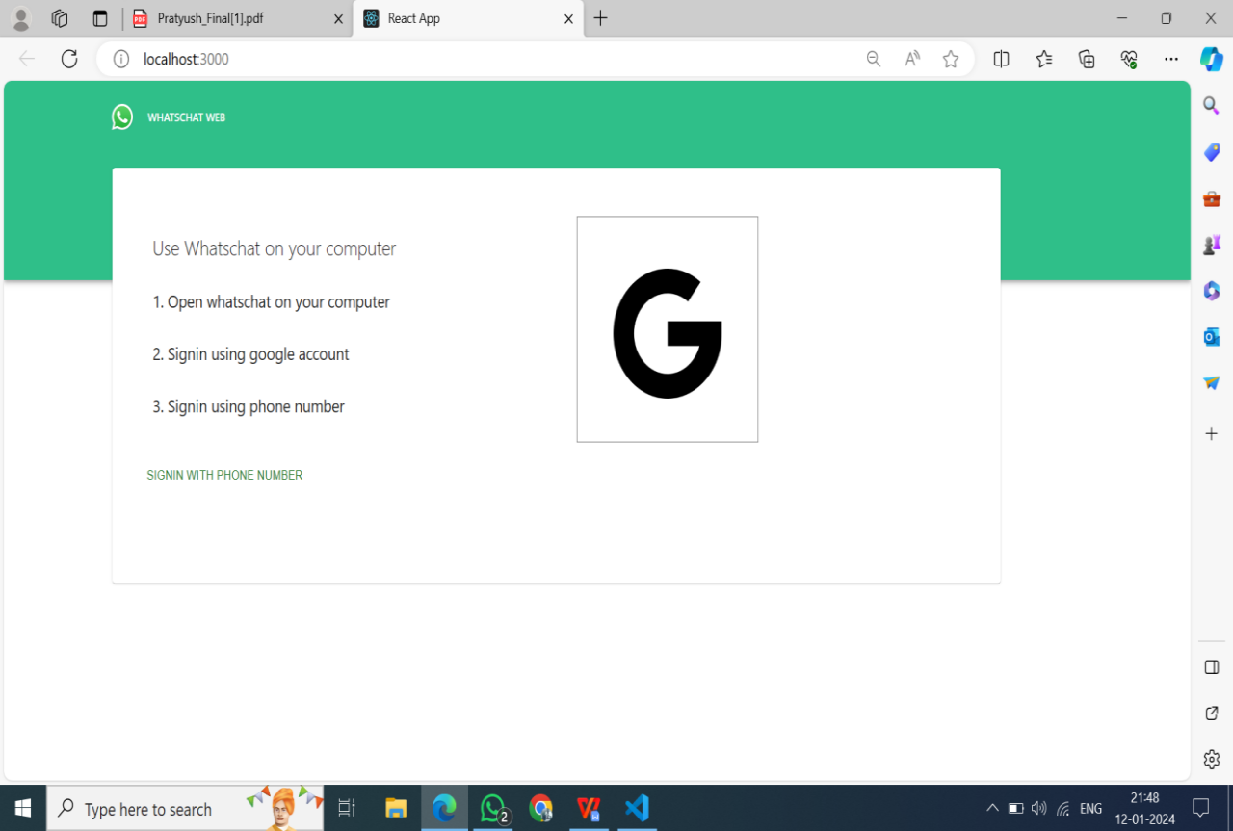

Figure 1: Landing Page

**6.2 USER AUTHENTICATION**

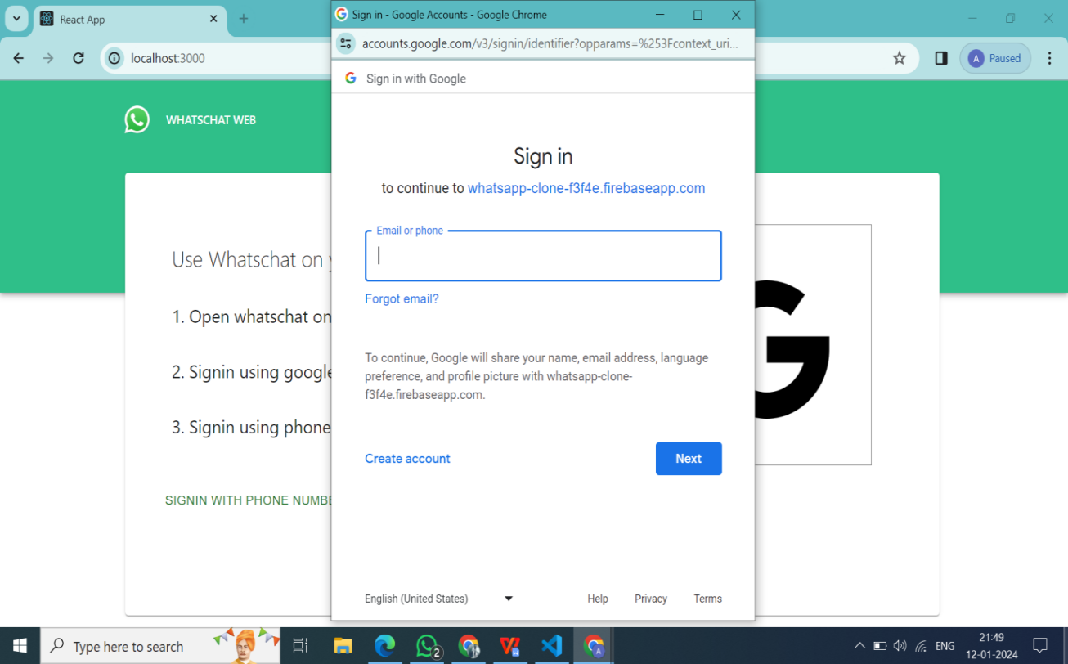

Figure 2: User Authentication for Login

**6.3 HOMEPAGE**

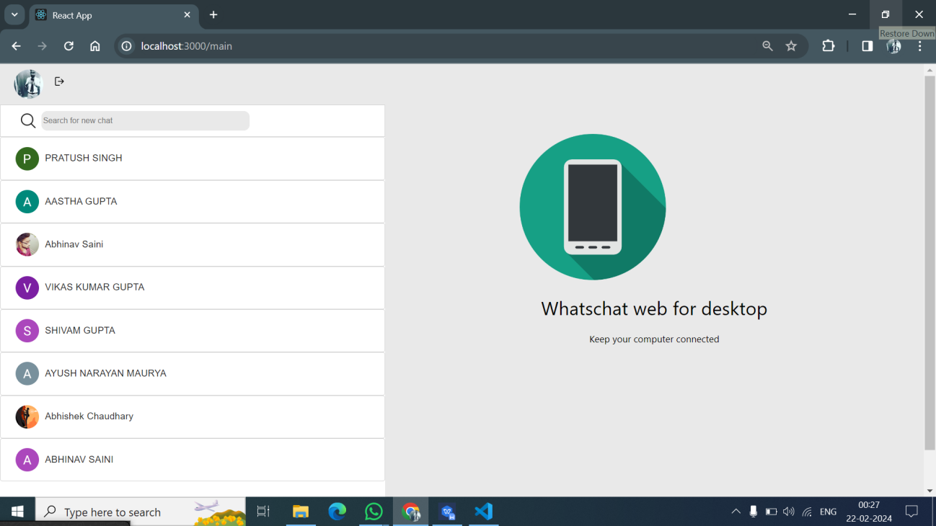

Figure 3: Home Page

**6.4 CHAT INTERFACE**

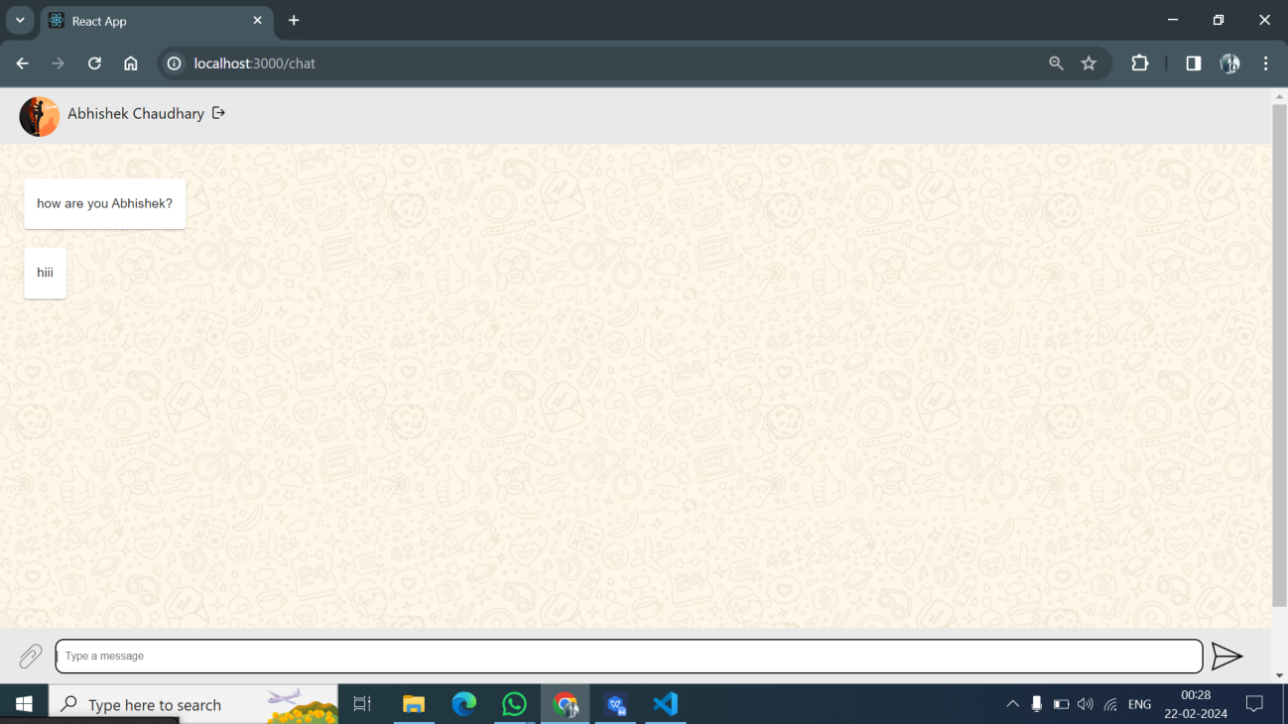

Figure 4: Chat Interface

# CHAPTER 7

# CONCLUSION

# WhatsApp Clone project amalgamates cutting-edge technologies, blending React.js, Material-UI, and Firebase to craft a responsive and secure messaging application. This fusion ensures a visually cohesive and user-friendly interface, promoting an intuitive user experience. Prioritizing security, the implementation of end-to-end encryption and token-based authentication safeguards user data and privacy. Real-time communication, powered by WebSocket connections or Firebase triggers, creates an interactive messaging environment. The scalable and maintainable architecture, emphasizing component modularity and hierarchical organization, sets the groundwork for future enhancements. Overall, the project exemplifies a successful union of technology and design, offering users a dynamic and secure platform for seamless communication.7.1 Future ScopeThe future scope of the WhatsApp Clone project involves implementing multimedia sharing, advanced group chat features, voice and video calling, and integrating emerging technologies like AR and VR. Enhancements in security measures, user customization, AI integration, and cross-platform compatibility are planned. Additionally, efforts will focus on localization, iterative improvements based on user feedback, exploring monetization strategies, and incorporating accessibility features. Data analytics, blockchain integration for enhanced security, and continual innovation will be central to ensuring the application remains at the forefront of the dynamic messaging landscape

# CHAPTER 8

# REFERENCES

**1. Official Documentation:**

* React.js: [React Documentation](<https://reactjs.org/docs/getting-started.html>)
* Firebase: [Firebase Documentation] (<https://firebase.google.com/docs>)
* Material-UI:[Material-UI Documentation] (started/introduction/)

**2. Online Tutorials:**

* YouTube – (https://youtu.be/WyVowwG5mrI?si=B3qaUlTiuNwHp94P)